Subscribing to free delivery service
___________________________________________________________________________________________________________________________________________________________
By subscribing to free delivery service, you will receive the periodical publication from AIDS Unit, Special Preventive Programme, Public Health Services Branch of Centre for Health Protection, Department of Health. You may return this application by fax (2338 0534), by email (rrc@dh.gov.hk) or by post to Red Ribbon Centre. Address :- 2nd Floor, 200 Junction Road East, Wang Tau Hom, Kowloon, Hong Kong
Free printed version is restricted for local mail only. Request for overseas delivery may send email to Red Ribbon Centre (rrc@dh.gov.hk) for special arrangement.
For subscription of printed version（Please put a | X | in the appropriate box）

 |  |  | Publication | Content
 |  |  | AIDS Newsletter | A half yearly publication in Chinese prepared by the Red Ribbon Centre for the public, youth and students.
 |  |  | The Node | A half yearly publication in Traditional Chinese, Simplified Chinese, and English dedicated to global HIV/AIDS issues by Red Ribbon Centre, the UNAIDS Collaborating Centre for Technical Support.
 |  |  | Red Ribbon Bulletin | A publication in Chinese published every 4 months, jointly produced by Integrated Treatment Centre HIV Clinical Team and people living with HIV/AIDS (PLHA), featuring articles and information of interest to PLHA.

* Name of recipient / Organisation | :
* Mailing address | :
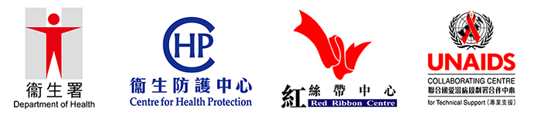
* Mandatory Fields
Personal Information Collection Statement
- The above information will only be used by Red Ribbon Centre for communication purpose.
- The personal data you provide are mainly for use within Red Ribbon Centre but they may also be disclosed with your consent to relevant parties if required.
- You have a right of access and correction with respect to the personal data as provided for in sections 18 and 22 and Principle 6 of Schedule 1 of the Personal Data (Privacy) Ordinance.
- For enquiries concerning personal data provided, including the making of access and corrections, please contact Red Ribbon Centre at Tel: 3143 7200 or via email (rrc@dh.gov.hk).
Last revision date: 05 March 2018

